**IBM Data Science Capstone Project**

**Predicting the price of Airbnb in New York**

**Introduction:**

New York is now becoming one of top 20 most visited city in the world. Tourists requires a places to stay and hotels rates are sometimes higher than they should or one can afford them, therefore now tourist prefer air bnb as they provide large area at affordable rates. In this project we **Predicting the price of Airbnb in New York** such that Airbnb will be profitable for everyone and tourist can also explore the venues around it.

**Data:-**

A dataset from kaggle to get list of Airbnbs in New York and to train model with it.

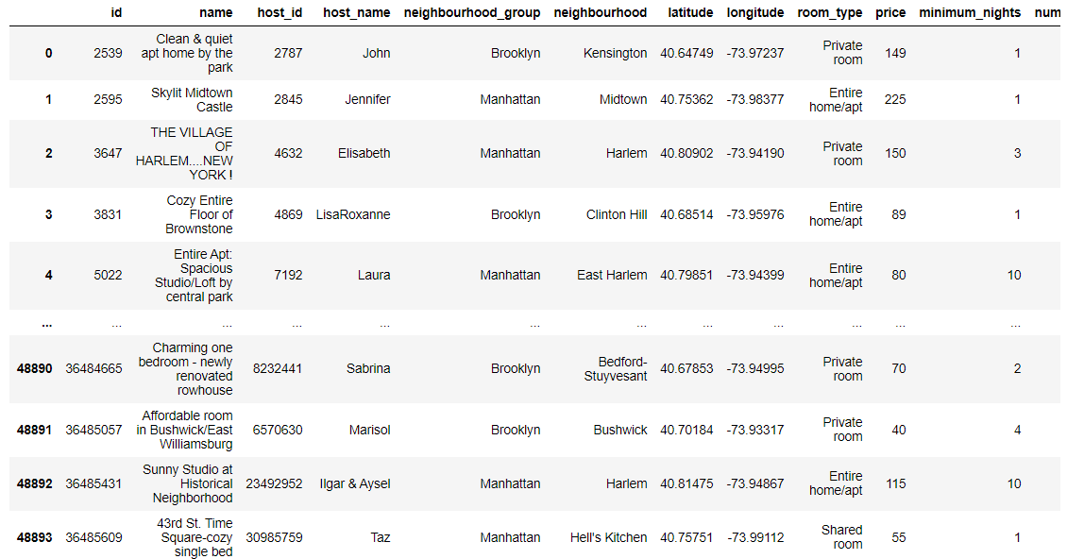

And Data from Foursquare Api to explore venues around the Airbnb

